

**Apoorva Modali**

**Kaushik Arunapuram**

**Pallav**

**Anand**

**Priyanka Srikanth**

Analysis of semi

-

conductor process

dataset using PCA and

Classification methods

**PROBLEM STATEMENT:**​

1. Detect and monitor pass/fail signals from sensors of a semiconductor manufacturing dataset using different analytical methods.
2. Learn new methods of solving classification problems and dimensionally reducing a large dataset.

**DATASET:**

SECOM data set (Link: ​http://archive.ics.uci.edu/ml/datasets/SECOM ​)

The data consists of 2 files the dataset file SECOM consisting of 1567 examples each with 591 features a

1567 x 591 matrix and a labels file containing the classifications and date time stamp for each example. As with any real life data situations this data contains null values varying in intensity depending on the individual features. This needs to be taken into consideration when investigating the data either through pre­processing or within the technique applied. The data is represented in a raw text file each line representing an individual example and the features separated by spaces.

**LITERATURE REVIEW:**

**Research Paper 1**

In this paper, a new adaptive sub statistical PCA model is proposed for semiconductor manufacturing process monitoring. By employing this method, several drawbacks of the conventional method are addressed. Time complexities and correlations among ASSP, MMPCA, and MPCA are analysed in detail. Advantages of the proposed method are that 1) cross­information between data blocks is modelled, while low time complexity is needed; 2) future value estimation is avoided; and 3)no Gaussian assumption of process data is needed. However, the proposed method is limited in linear and stationary cases. Consideration of how to extend it for nonlinear and dynamic process monitoring is still under way. **Research Paper 2**

The paper analyses fault detection accuracy in semiconductor manufacturing process. The sensors give 590 features which can be used for fault prediction. The paper proposes a feature section method to filter out irrelevant predictors. They also propose a boosting technique to handle the skewness of pass versus fail tests. The wafer fabrication data collected from 590 sensors with the last feature is a label stating pass or fail state. The 1567 observations contain 1463 pass cases and only 104 fail cases. The features which have constant value or have more than 55% missing values are removed first. In the cleaning step, we remove 137 features that contain a single value and lots of missing values. Further feature selection is done using statistical based analysis such as chi­square and principal component analysis (PCA) and information theoretical based such as gain ratio. A cluster based technique called MeanDiff is also used to analyse discrimination power of each feature.

From the remaining 454 features, we select the best 168 features (to maintain around 95% of variances) by means of principal component analysis (PCA), Chi­square test, gain ratio computation, and our own MeanDiff method. Before applying models it uses “case boosting” to reduce the skewness of pass vs fail cases.

Four methods are used to induce the fault­detection model namely decision tree, naïve Bayes, logistic regression, and k­nearest neighbour. For assessing the model performance four metrics are used: true positive rate (TP rate or recall), precision, F­measure, and false positive rate (FP rate or false alarm). We want the model that shows the highest values of TP rate, precision, and F­measure, but the lowest value in FP rate. WEKA software was used to perform a series of experiments.

The proposed MeanDiff method contributes the most to decision tree model, whereas the gain ratio method is the best feature selection method for the naive Bayes and logistic regression model building approaches. The k­nearest neighbour method (in which k was set to be one on our experiments because it yields the best result) needs a cleaned dataset without any other feature selection facility. Among the four model building methods, naïve Bayes model can detect fault cases at the success rate as high as 90%, but the false alarm (FP rate) is also as high as 80% as well.

**Research Paper 3**

Support vector machine is a well­known technique in the field of machine learning which is used for classification. Implementing nonlinear kernels in the SVM structure enables classification of nonlinear data which cannot be classified by simple linear classifiers. SVM algorithm is usually used for twoclass separation problems. In K­nearest neighbour classification, the class of each sample point is determined by its K neighbouring points in the training set. The point is assigned to the class with the majority of votes for class label amongst the K­neighbour points. The classifier is defined by its parameters. Setting parameter K depends on the data and effects the performance of the classifier. K must be large enough to reduce misclassification.

In this paper, the experiment data was conducted on the well­established Tennessee Eastman Process and Three tank system data sets. In every fault detection and diagnosis system, the FDI process includes detecting the fault in the process and then identifying the type of the fault. Here, the focus was on the diagnosis part of the FDI process and assume that fault detection has been accomplished. After fault detection stage in FDI, SVM was used for fault classification. The performance of the C­SVM compared to simple SVM with different kernels and also to K­nearest neighbour classifier is compared. Hence, a training and a testing data set is collected from the processes. The choices of different SVM depend on their parameters. Type of the kernel, value of C, width of the RBF kernel, polynomial kernel degree, and number of SVM to be used in the committee are such example parameters. Since there are many different combinations to choose, they only restricted the experiment to a simple case with three different kernels to be used in the SVM­classifier.

The procedure for building the classifier is as follows: For every two faults they trained a C­SVM classifier. Each classifier is a combination of three SVM with different kernels (linear, RBF, polynomial), trained with data that are a mixture of the two fault class data set. The output is simply the average of the three. It can be clearly seen that using a classifier that is a combination of all the three proves to be the best in this case. However, for further confirmation, the method should be tested on other different processes in order to achieve a comprehensive understanding of the proposed method.

**Research Paper 4**

In this paper, a fault detection method has been proposed by combining random projection and k nearest neighbour rule. The proposed method not only can reduce the computational complexity and storage space, but also approximately guarantee the advantages of kNN rule in dealing with the problems of multimode batch trajectories and nonlinearity that often coexist in semiconductor processes. It is worth noting that the idea of using random projection for reducing computation of kNN classification is not new. However, the idea of combining random projection with kNN for fault detection (one­class classification) of semiconductor processes, to our knowledge, should have no publication before. The proposed method should be seen as an alternative fault detection method. It is not superior to PCA in all cases. Some interesting future work: To exploit the ability of kNN for isolating faulty variables and estimating the fault magnitude. Once a fault is detected, the next step is to identify faulty variables which are attributed to this fault. One can also define the variable contribution for the kNN distance in the light of the idea of contribution plots. And the estimation of fault magnitude is useful for fault tolerant control. The distances from normal samples are, to a certain extent related with fault magnitude. To apply RPkNN to other batch or continuous processes. The proposed method is not limited to semiconductor processes, it can also be applied to other high dimensional batch processes and continuous processes.

**APPROACH**

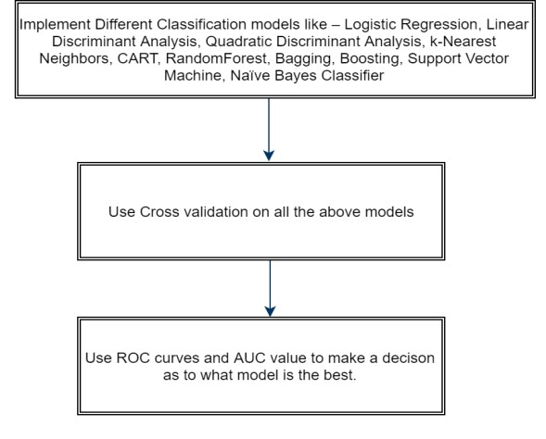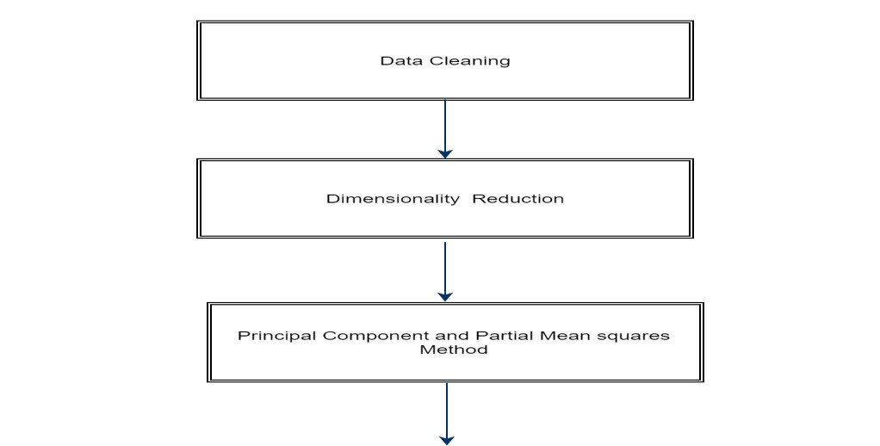

**IMPLEMENTATION**

**The dataset is loaded onto R. The dataset has 1567 observations and 591 variables.**

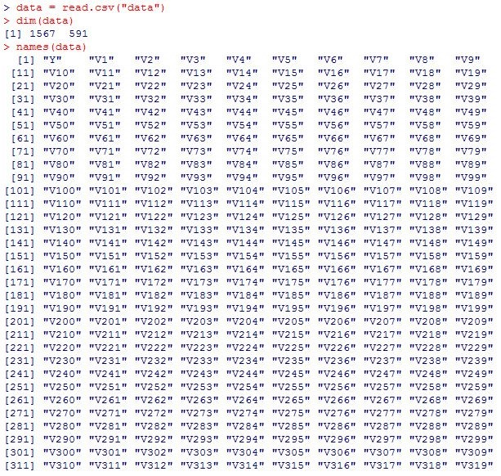

**We could observe that there are missing values present in the dataset. Using the below code, we identified the names of the variables containing the missing values and omitted them. We transformed those values to a new set of constant values. The columns which contains these**

**constants were omitted, as the variance of those constants is always zero. The new data obtained has a total of 53 variables as shown below.**



**Dimensionality Reduction:**

We employed the process of Principal Component Analysis to reduce the dimensionality of the dataset. The summary of the code obtained is as shown below.

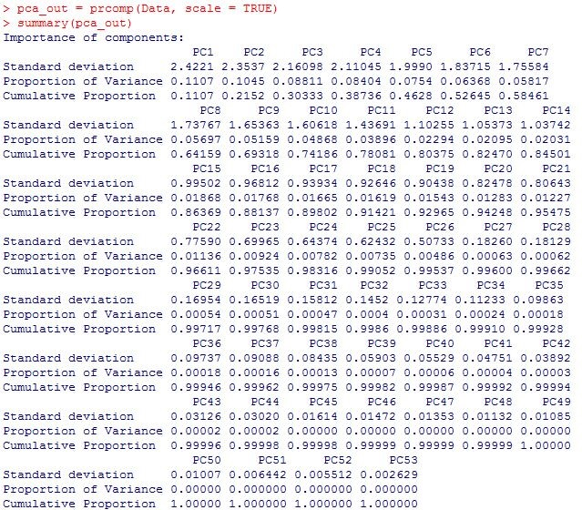

Center corresponds to the mean, sdev gives the standard deviation and rotation corresponds to the directional cosines of the respective principal components.

We then employ the method of “Scree Plot” to find out the optimal number of principal components.



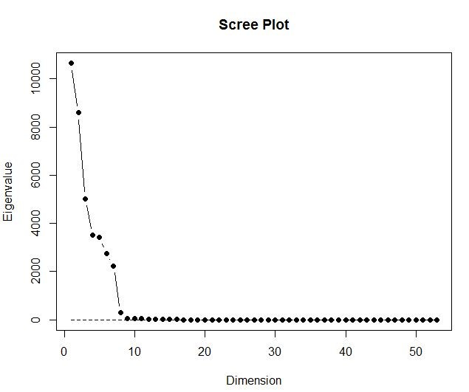

**We can infer from the Scree plot that the optimal number of principal components required are 9.** When a linear regression model was fitted onto the above obtained PCA model, we get the following results:

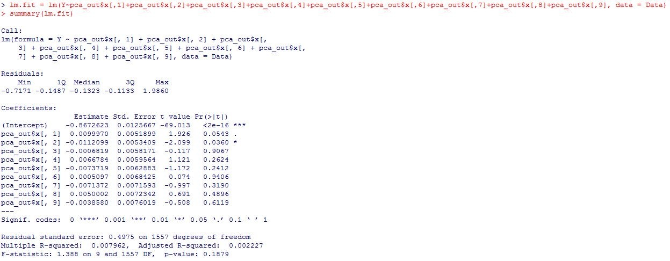

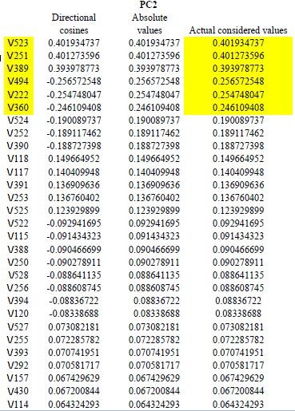

We can conclude that 2​nd​ Principal component is the most significant of all the principal components.

With further analysis, we found out that the important variables to be considered are : V523, V251, V389, V494, V222, and V360. We will be building our further models by taking different combinations of these variables to obtain best prediction performance and to also study the features responsible for the failure of the semiconductor devices.

# Splitting into Training and Testing datasets

The entire dataset is split into a separate training and test data. 80% of the observations are termed as the training data and the remaining 20% is the test data using the following code.

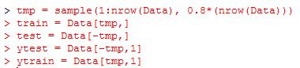

# CLASSIFICATION MODELS

## 1. Logistic Regression

The method of logistic regression is done to all the important set of predictors. After several iterations, we get the best model with a combination of predictors: V523,V251,V389,V494,V222,V360. The summary of the output of the model is as shown below.

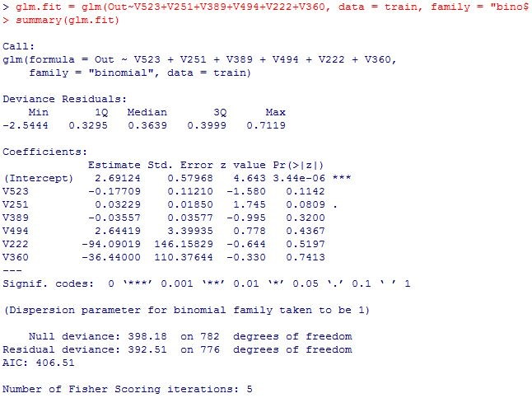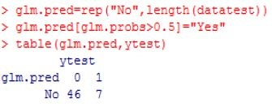

**Cross Validation:**

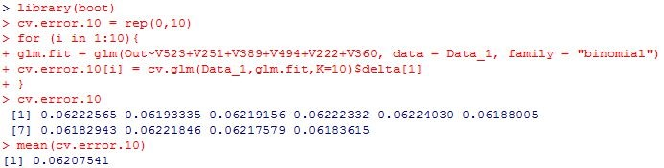

The error rate after cross validation, is 6.2075%

|  |  |
| --- | --- |
| **Predictors used** | **Error Rate** |
| V523,V251,V389,V494,V222,V360 | 6.2075% |

## 2. Linear Discriminant Analysis(LDA)

From the main predictors chosen, we found that the best model possible from the method of LDA is when we use the predictors: V523,V251,V389,V494,V222,V360.

The summary of the model obtained is as shown below.

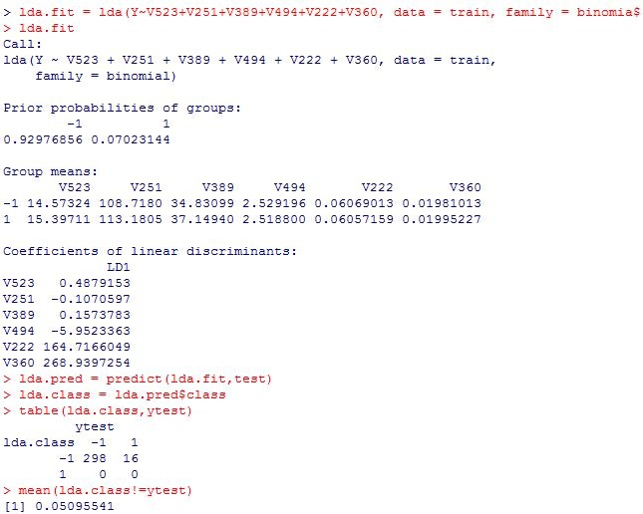

The classification error rate is 5.0955%.

**Cross Validation:**

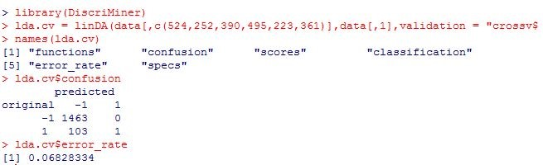

After cross validation, the classification error rate is 6.8283%.

|  |  |  |
| --- | --- | --- |
| **Predictors used** | **Error Rate** | **CV Error Rate** |
| V523,V251,V389,V494,V222,V360 | 5.0955% | 6.8283% |

## 3. Quadratic Discriminant Analysis

From the main predictors chosen, we found that the best model possible from the method of LDA is when we use the predictors: V251,V389.

The summary of the model obtained is as shown below.

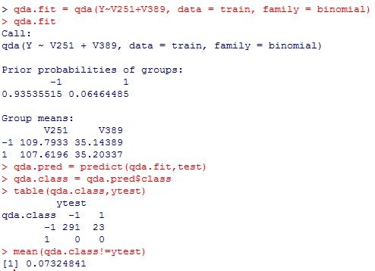

The classification error rate is 7.3248%.

**Cross validation:**

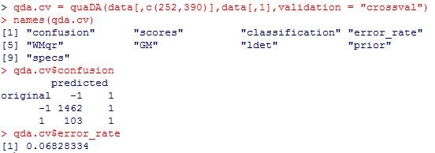

The cross validated classification error rate is 6.8283%.

|  |  |  |
| --- | --- | --- |
| **Predictors used** | **Error Rate** | **CV Error Rate** |
| V251,V389 | 7.3248% | 6.8283% |

## 4. K­Nearest­Neighbour (KNN) Method

An iterative procedure is done for the following cases: k=1, k=2 and k=3. We find that the best model is obtained for the case when k=3.

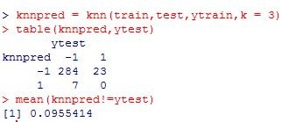

The classification error rate obtained is 9.5541%.

**Cross validation:**

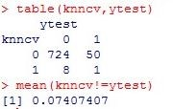

The cross validated classification error rate is 7.4074%.

|  |  |
| --- | --- |
| **Error Rate** | **CV Error Rate** |
| **9.5541%** | **7.4074%** |

## 5. Classification and Regression Tree (CART)

Tree ­ based models are popular for their interpretability and hence we are not just considering the variables which are the highly significant from the principal component analysis but are going to consider all the variables present in the data set. The summary of the model obtained is as shown below and the variables considered for the tree are shown in the summary. We can interpret the model as if the value of the variable V292, which is the most significant one is less than 0.03515 and V430 is less than 4.87605, the semiconductor device is more likely to fail. Feature selection for process improvement activities could be obtained from tree ­ based models.

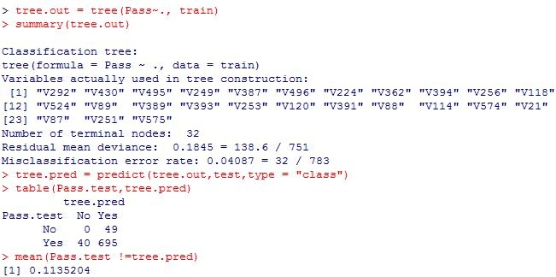

​The classification error rate obtained is 11.352%.

**Pruning:**

**Cross ­ Validation with pruning could be considered for better tree selection.**

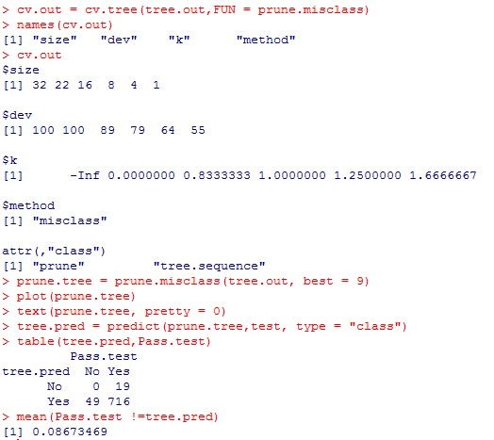

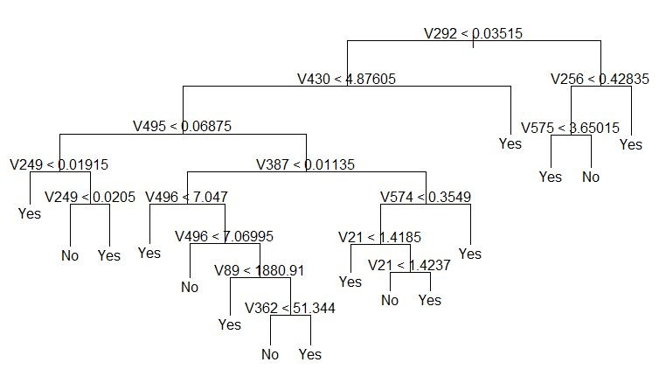

The plot of the pruned tree is as shown in the figure above. The classification error rate is 8.6734%.

|  |  |  |
| --- | --- | --- |
| **Variables used for tree construction** | **Error Rate** | **Pruned Tree ­ CV Error Rate** |
| V292,V430,V495,V249,V387,V496,V224,V362,V3  94,V256,V118,V524,V89,V389,V393,V253,V120,V  391,V88,V114,V574,V21,V87,V251,V575 | 11.352% | 8.6734% |

## 6. Bagging and Random Forest

After several iterations, the best model with the lowest classification error rate is obtained which is as shown below. The predictors used for this model are V523,V251,V389,V494,V222 and V360.

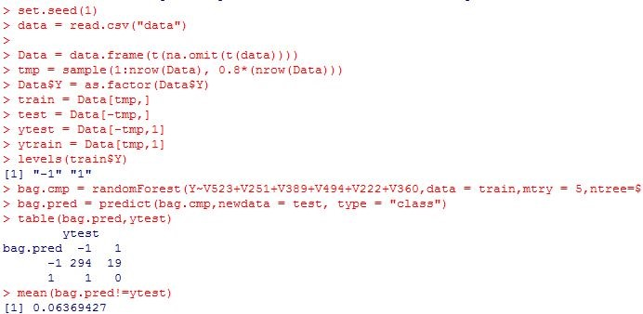

The classification error rate obtained is 6.3693%.

|  |  |
| --- | --- |
| **Predictors used** | **Error Rate** |
| V523,V251,V389,V494,V222,V360 | 6.3694% |

## 7. Boosting

Boosting model was studied on the dataset but the model failed to provide good prediction performance

which can be seen from the below results. The predictors used for this model are

V523,V251,V389,V494,V222,V360.

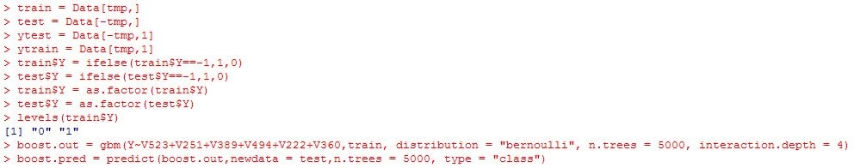

The classification error rate obtained is 15.0593%.

|  |  |
| --- | --- |
| **Predictors used** | **Error Rate** |
| V523,V251,V389,V494,V222,V360 | 15.0593% |

## 8. Naïve Bayes Classifier

The Bayesian Classification represents a supervised learning method as well as a statistical method for classification. Assumes an underlying probabilistic model and it allows us to capture uncertainty about the model in a principled way by determining probabilities of the outcomes. It can solve diagnostic and predictive problems. This Classification is named after Thomas Bayes ( 1702­1761), who proposed the Bayes Theorem. **Algorithm:**

Naive Bayes classifier understands that the effect of the value of a predictor ‘x’ on a given class ‘c’ is independent of the values of other predictors. Bayes theorem provides a way of calculating the posterior probability, P(c|x), from P(c), P(x), and P(x|c).

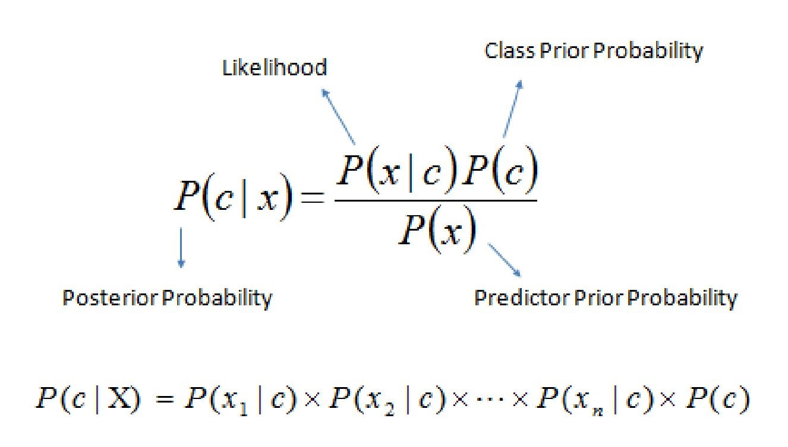

Where,

* *P*​(​*c|x*​) is the posterior probability of ​*class*​ (*target*​ ​) given *predictor*​ ​ (*attribute*​ ​).
* *P*​(*c*​​) is the prior probability of ​*class*​.
* *P*​(*x|c*​​) is the likelihood which is the probability of ​*predictor*​ given *class*​ ​.
* *P*​(​*x*​) is the prior probability of ​*predictor*​.

We have tried to incorporate this concept into our model and applied Naive Bayes Classification on our dataset. We studied the classifier using different sets of significant predictors and the best below is selected after the study. We also applied 10 fold cross validation technique with our classifier and studied the prediction performance. The output for the best model with the least misclassification rate is as shown below.

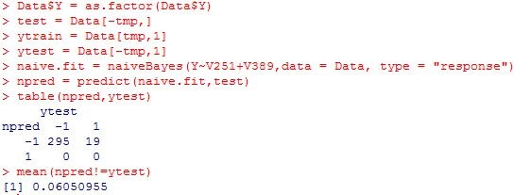

The classification error rate obtained is 6.0509%.

**Cross validation:**

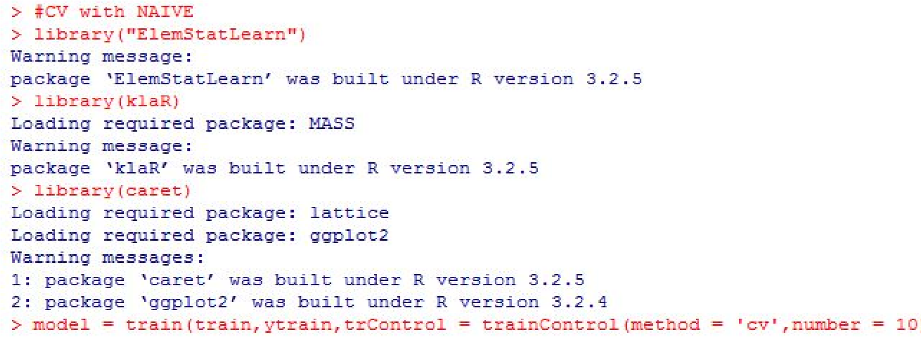

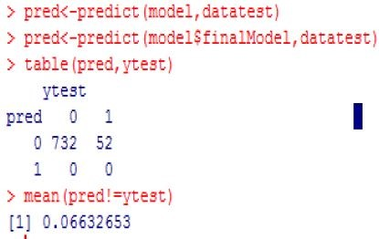

The classification error rate obtained is 6.6326%.

|  |  |  |
| --- | --- | --- |
| **Predictors used** | **Error Rate** | **CV Error Rate** |
| V251, V389 | 6.0509% | 6.6326% |

## 9. Support Vector Machine (SVM)

The model was incorporated iteratively with a combination of predictors and also used different kernels such as “linear” and “Radial”at a time. The best cost parameter and the gamma value are chosen by studying the summary of each of the SVM models using different kernel functions. The best model found was a model with radial kernel and the predictors: V523,V251,V389,V494,V222 and V360.

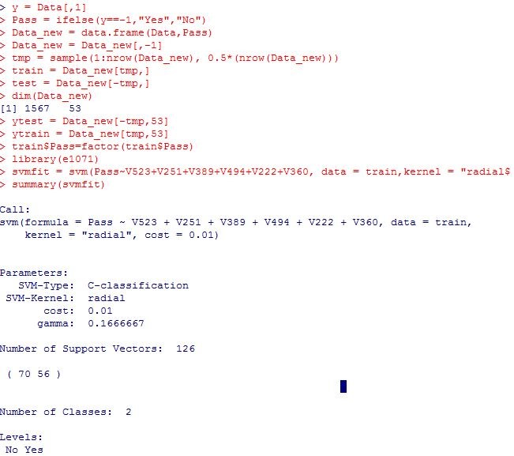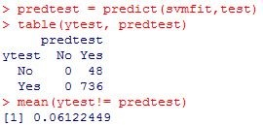

**The classification error rate obtained is 6.1224%.**​ We employed the method of cross validation, though we didn’t get any distinguishing parameters and hence, we conclude our best model with radial kernel only based on the misclassification rate from the model.

**RESULTS AND CONCLUSIONS**

A summary of the various methods used and their respective error rates is as shown below.

|  |  |
| --- | --- |
| **METHOD** | **MISCLASSIFICATION RATE** |
| **Naive Baye’s Classifier** | **6.6326%** |
| **Logistic Regression** | **6.2075%** |
| **Linear Discriminant Analysis** | **6.8283%** |
| **Quadratic Discriminant Analysis** | **6.8283%** |
| **k­Nearest Neighbours (kNN)** | **7.4074%** |
| **CART** | **8.6734%** |
| **Bagging and Random Forest** | **6.3775%** |
| **Boosting** | **15.0593%** |
| **Support Vector Machine(Radial Kernel)** | **6.1224%** |

After studying the sensitivity, specificity, the classification error rate and the interpretability of each model, we can conclude that the best method is the **Support Vector Machine method with Radial kernel for forecasting purposes**​. We observe the lowest error rate to be 6.1224% according to this model. The error rates vary from a factor of +/­ 1% when the model is run a multiple number of times. Hence the SVM(Radial Kernel) could be used for forecasting whether the semiconducting device would fail and the Tree­Based models could be used for feature selection which give us more interpretability of significant variables causing the failure of the semiconductor device. In the studied dataset we observe that the variable and/or signals that mainly influence the device failure are V292, V430 and V495. These signals may be used to determine key factors contributing to yield excursions downstream in the process which will enable an increase in process throughput, decreased time to learning and reduce the per unit production costs.